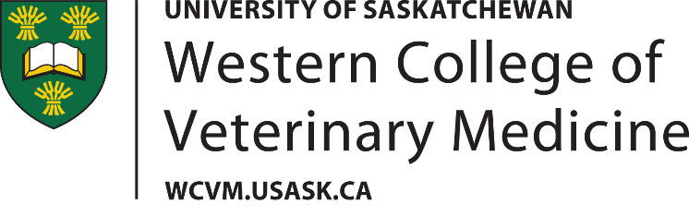
MERCK ANIMAL HEALTH FUND
Letter Of Intent

- Deadline: June 15th, or the first Monday thereafter if the 15th falls on a weekend.
- LOI’s are to be submitted via WCVM research website https://wcvm.usask.ca/research/overview.php.
- Applicants selected to submit a full proposal will be notified by July 5th
- Full proposals for selected LOIs will be due Sept 15.
- Topics for research are limited to the following for this year:
  - Tick species and potential tick-borne disease risks in Southern Saskatchewan
  - Leptospirosis in clinically ill, unvaccinated dogs
  - Histophilus somni in feedlots
  - Pain mitigation in bull castration
  - Colostrum/transition milk in subsequent feedings to dairy calves
  - BVDv typing surveillance
  - Prevalence/significance of cryptosporidiosis in young calves (beef or dairy)

- LATE OR INCOMPLETE LOI’S WILL NOT BE CONSIDERED.

- Summary Information:
Name:
Title of Project:
- Letter of intent - Proposed Research Project:
(Provide an overview of the research project along with objectives and goals – maximum 1 page, 12-pt font, single-spaced)

3. Budget:

Expenditure | Total Amount  Requested ($) | Total Amount  Other Sources($) | Details And Justification  (Maximum 170 Characters, Including Spaces.)

1. Animals

2. Animal care

3. Materials and supplies

4. Personnel costs

5. Laboratory services

6. Travel

7. Other (specify)

8. Other (specify)

Total funds requested

(Maximum $25,000 from Merck)

